WORLD GROWTH MANAGEMENT FUND LTD
Company No(LL14049)
项目分析指数 | *****

项目公司：腾讯控股有限公司 | 项目编号：00001 | 日期：05/02/2018 | 发布时间：6:02pm

腾讯控股 | （00700） | 交易股数量：  (Stock Trading) | 10,000.00股 share
规模资金：  (Size of Fund) | HKD4,700,000.00 | 货币  (Currency) | HKD

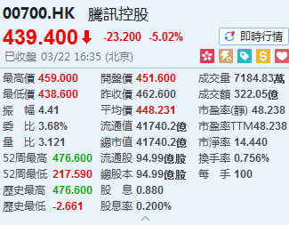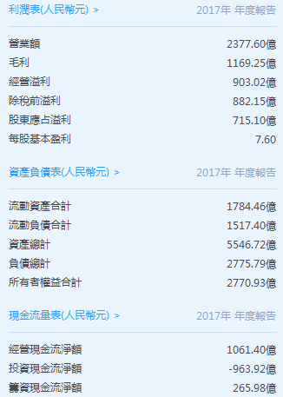

腾讯控股(00700.HK)：2018年有的放矢;长期化潜力可期
(Targeting 2018; Long-term potential Expected)
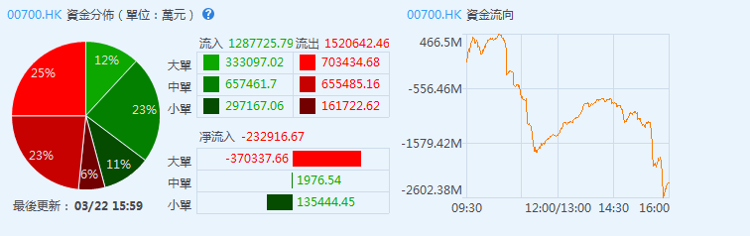
基金会融资 (Foundation of Fund)
项目资金规模  (Funding Scale) | 总股本  (Share Capital) | 每手  (Each Lot) | 每股  (Per Share Price)
HKD4,700,000.00 | 10,000份股 | 100股 share | HKD47,000.00

利息协议锁定期 (Interest Agreement locking period)
18个月 (18-Month) |  | 36个月 (36-Month)
12个月 | 7.8% | 12个月 | 7.8%
6个月 | 3.9% | 12个月 | 7.8%
 |  | 12个月 | 7.8%
该基金企图达成提供每年7.8%的定期收入的目的。
The fund are achieve to provide 7.8% of fixed interest rate each year

演出获利比率 (Performance Fee Profit ratio)
认购者 (Subscriber) | 基金会 (Fund Management)
70% | 30%
业绩费用必须是该基金在该业绩期间的资产净值升值的百分之三十30%任何买回及分发的调整。
The performance fee must be 30% of the fund's Net Asset Value (NAV) during that performance period and with any dealing adjustments in conditions.

预期项目涨势分析 (Expected Inflation Analysis)
18个月 (18-Month) | 36个月 (36-Month)
8%~15%++ | 24%~45%++
根据项目涨势预测。
Expected Inflation rate based on Forecast.

预期项目涨势分析资产 (Expected Assets Analysis)
认购者18个月预期资产  (Subscriber's 18-month expected assets) |  |  | 认购者36个月预期资产  (Subscriber's 36-month expected assets)
4,700,000.00 | 8% | 376,000.00 | 4,700,000.00 | 24% | 1,128,000.00
4,700,000.00 | 15% | 705,000.00 | 4,700,000.00 | 45% | 2,115,000.00
基金演出分享利润备忘录：认购者得70%利润分享基金会得30%利润分享，资产净值是根据所有基金会资产在估值价上的价值扣除所有基金负债的价值来确定。
Fund Performance Fee Profit Sharing Memorandum: Subscribers get 70% profit sharing, whereby Management Fund Ltd. get 30% profit sharing.
The Net Asset Value (NAV) is determined by deducting the value of all fund liabilities based on the value of all fund assets from the valuation price.

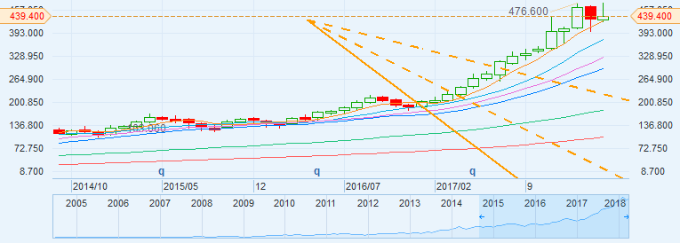

腾讯控股业务体系：
金融
财付通 | 微信支付 |  | QQ钱包 | 理财通 | 微黄金
（社交业务）
QQ,微信 |  | QQ空间 | 腾讯微博

娱乐
腾讯游戏 | 腾讯影业 |  |  | 腾讯动漫 | 腾讯电竞 |  | 阅交集团
qq音乐 | 腾讯视频 |  |  | 腾讯体育 | 企鹅电竞 |  | Now直播
兴趣部落 |  |  | 腾讯课堂 |  |  | 企鹅FM

资讯
腾讯网 |  | 腾讯新闻 | 天天快报

工具
应用宝 |  | QQ浏览器 | 手机管家 | 电脑管家
腾讯地图 |  | QQ邮箱 | 自选股 | 天天P图

平台
开放平台 |  | 腾讯云

人工智能
腾讯AL lob |  | 腾讯云

风险因素
这部分风险是基于风险发生的可能性与风险的影响相结合的评估。没有保证或保证不同风险的重要性不会改变或其他风险不会增加。
在投资之前，您应该考虑或寻求第三方咨询该投资是否是一个适合您作为投资人的投资。与此投资相关的风险以及其他更多的是在管理人和该基金的控制范围以外。
政治风险
该基金的表现可能受到经济和市场条件的变化、政治发展、军事冲突和内乱等不确定因素，政府政策的变化对资本转移的限制以及法律、监管和税收要求方面的影响。
货币风险
该基金可以投资以该基金基础货币以外的货币计价的资产。因此，由于不同货币的汇率波动，股东投资的价值可能受到有利或不利的影响，因为基金基础货币与指定货币之间的汇率变动可能导致以所确定的货币表示的股份价值。
大幅买回的可能产生的影响
参与股份的大幅买回可能要求该基金更快速地清算其头寸以筹集资金买回所需的现金。某些证券流动性不足可能导致该基金很难以有利的条件清算头寸，这可能导致基金资产净值的损失或减少。当该基金决定为此目的而清算证券投资组合时，该基金获准借入与买回股份有关的所需款项。该基金也被授权将抵押品作为抵押品用于偿还这些贷款，在这种情况下，持续的股东将承担基金资产价值随后出现下跌的风险。

RISKS FACTORS
This section of risks has been based in an assessment of a combination of the probability of the risk occurring and the impact of the risk if it did occur. There is no guarantee of assurance that the importance of different risks will not change or that other risks will not arise.
Before investing, you should consider or seek third party advice whether this investment is a suitable investment for you as an investor. There are risks associated with this investment and many of which are outside of the control of the Manager and the fund.

POLITICAL RISKS
The performance of a Fund may be affected by changes in economic and market conditions, uncertainties such as political developments, military conflict and civil unrest, changes in government policies, the imposition of restrictions on the transfer of capital and in legal, regulatory and tax requirements.

CURRENCY RISKS
A Fund may invest in assets that are denominated in a currency other than the Fun’s Base Currency. Therefore, due to exchange rate fluctuation in different currencies, the value of Shareholder’s investment may be affected favorably or unfavorably, as changes in the exchange rate between the Base Currency of a Fund and the designated currency may lead to a depreciation of the value of such Shares as expressed in the designated currency.

POSSIBLE EFFECT OF SUBSTANTIAL REDEMPTIONS
Substantial redemption of Participating Shares could require the Fund to liquidate its positions more rapidly than otherwise desired in order to raise the cash necessary to find the redemptions. Liquidity in certain securities could make it difficult for the Fund to liquidate positions on favorable terms, which could result in losses or a decrease in the Net Asset of the Fund. The Fund is permitted to borrow cash necessary to make payments in condition with redemption of Shares when it determines that it would not be advisable to liquidate portfolio assets for that purpose. The Fund is also authorized to pledge portfolio assets as collateral security for the repayment of such loans. In these circumstances, the continuing Shareholders will bear the risk of any subsequent decline in the value of the Fund’s assets.

